********************************************************************************
Excersise 8
Aim: Apply naïve bayes classifier on a given data set (wheather.nominal)
Reg No. 24251115
Date 18-05-2025
********************************************************************************
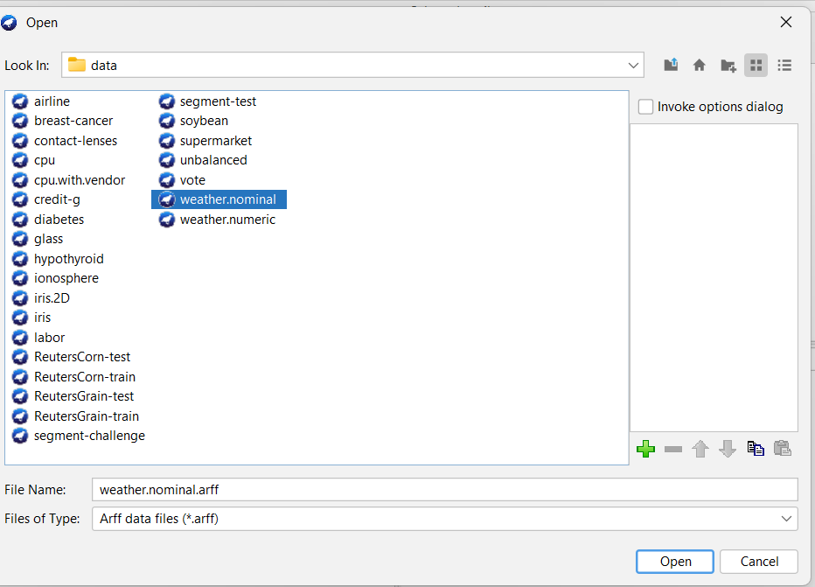
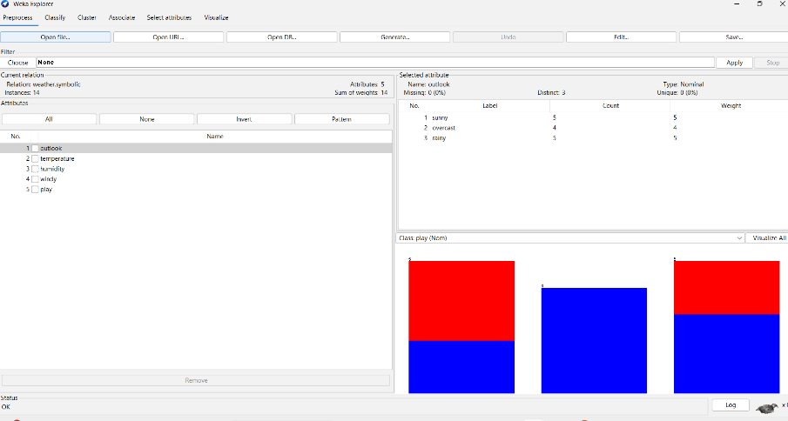

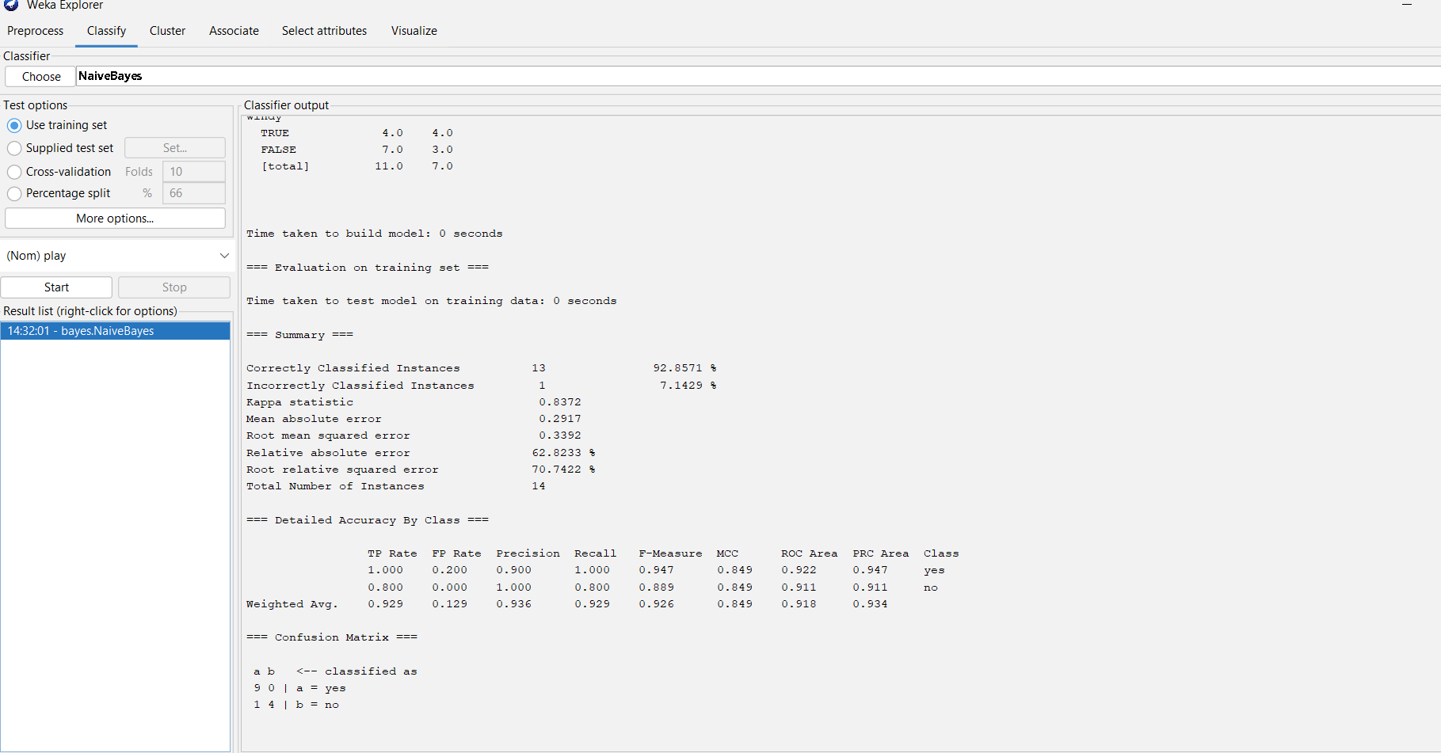
********************************************************************************
Excersise 11
Aim: A movie producer is bringing out a new movie. In order to map out advertising campaign, he wants to determine whether the movie will approx. most to particular age group or whether it will appeal equality to all age grot. The producer takes a random sample from person attending preview of the new movie obtains the following result
Year | Under 20 | 20-39 | 40-59 | 60 and over
Liked | 146 | 78 | 48 | 98
Disliked | 54 | 22 | 42 | 92
Indifferent | 20 | 10 | 10 | 20
Total | 220 | 110 | 100 | 70

Reg No. 24251115
Date 18-05-2025
********************************************************************************
# Create the data as a matrix
movie_data <- matrix(c(
146, 78, 48, 98, # Liked
54, 22, 42, 92, # Disliked
20, 10, 10, 20 # Indifferent
),
nrow = 3, byrow = TRUE)
# Add row and column names
rownames(movie_data) <- c("Liked", "Disliked", "Indifferent")
colnames(movie_data) <- c("Under 20", "20-39", "40-59", "60 and over")
# View the matrix
print("Contingency Table:")
print(movie_data)
# Perform Chi-square test of independence
chi_test <- chisq.test(movie_data)
# Output the test result
print("Chi-square Test Result:")
print(chi_test)

Output:
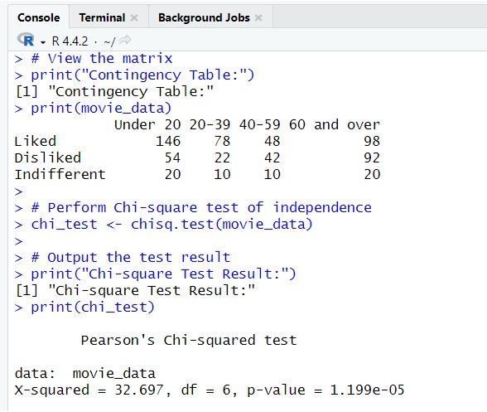

********************************************************************************
Excersise 18
Aim: R code to find Mean, Median, Mode of the Grouped data with class Interval
Reg No. 24251115
Date 18-05-2025
********************************************************************************
# Class intervals and frequencies
lower <- c(0, 10, 20, 30, 40)
upper <- c(10, 20, 30, 40, 50)
frequency <- c(5, 8, 15, 10, 7)

# Midpoints
midpoints <- (lower + upper) / 2

# Mean
mean_val <- sum(midpoints * frequency) / sum(frequency)

# Cumulative frequency
cum_freq <- cumsum(frequency)
N <- sum(frequency)

# Median
median_class_index <- which(cum_freq >= N/2)[1]
L <- lower[median_class_index]
F <- ifelse(median_class_index == 1, 0, cum_freq[median_class_index - 1])
f <- frequency[median_class_index]
h <- upper[median_class_index] - lower[median_class_index]
median_val <- L + ((N/2 - F) / f) * h

# Mode
modal_class_index <- which.max(frequency)
L_mode <- lower[modal_class_index]
f1 <- frequency[modal_class_index]
f0 <- ifelse(modal_class_index == 1, 0, frequency[modal_class_index - 1])
f2 <- ifelse(modal_class_index == length(frequency), 0, frequency[modal_class_index + 1])
h_mode <- upper[modal_class_index] - lower[modal_class_index]
mode_val <- L_mode + ((f1 - f0) / ((2 * f1) - f0 - f2)) * h_mode

# Output results
cat("Mean =", mean_val, "\n")
cat("Median =", median_val, "\n")
cat("Mode =", mode_val, "\n")

OUTPUT :
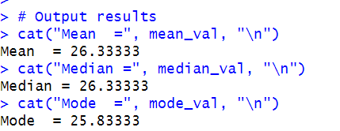

********************************************************************************
Excersise 19
Aim: The following table givens indices of industrial production of registered unemployed (in hundred thousand). Calculate the Karl Pearson’s coefficient correlation.
Year | Index of Production | No. of unemployed
1991 | 100 | 15
1992 | 102 | 12
1993 | 104 | 13
1994 | 107 | 11
1995 | 105 | 12
1996 | 112 | 12
1997 | 103 | 19
1998 | 99 | 26

Reg No. 24251115
Date 18-05-2025
********************************************************************************
x=c(100,102,104,107,105,112,103,99)
y=c(15,12,13,11,12,12,19,26)
sum_x=sum(x)
sum_y=sum(y)
sum_xsq=sum(x^2)
sum_ysq=sum(y^2)
sum_ofXY=sum(x*y)
n=length(x)
corr_coeff=(n*sum_ofXY-(sum_x*sum_y))/sqrt((n*sum_xsq-
(sum_x^2))*(n*sum_ysq-(sum_y^2)))
print(corr_coeff)
print(summary(x,y))
plot(x~y)

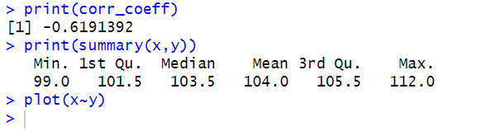
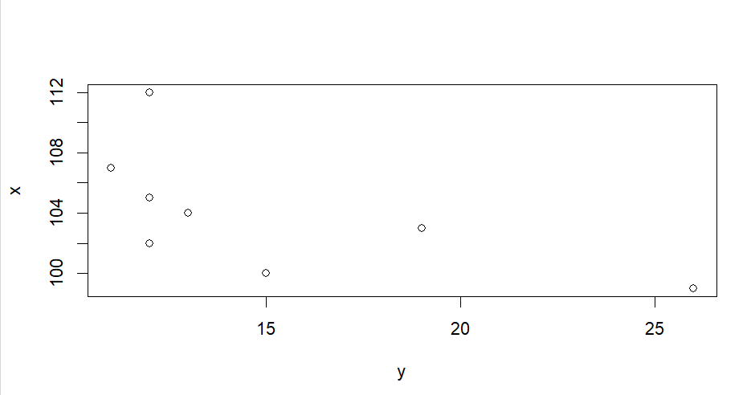

********************************************************************************
Excersise 20
Aim: Design a knowledge flow to load a data set using batch mode and perform cross validation using Bayesian classifier.
Reg No. 24251115
Date 18-05-2025
********************************************************************************
1)Open weka->knowledge flow->new layout.
2)Go to left panel->data sources->drag and drop ArffLoader.
3)Again come to the left panel,select Evaluation ->drag and drop ClassAssigner.
3)In ArffLoader(right click)->configure(browse any data set)->ok.
4)connect from Arffloader to ClassAssigner[right click ArffLoader->dataset(connect)
5)Evaluation->CrossValidationFoldMaker (drag and drop)->right click on ClassAssigner->dataset(connect).
6)Classifiers->bayes->naivebayes(drag and drop)->right click on CrossValidationFoldMaker->training test&testset->connect.
7)GoTo Evaluation-> ClassifierPerformanceEvaluator (drag and drop)->right click on NaiveBayes->Batchclassifier(connect).
8)Visualization->TextViewer(drag and drop)->rifht click on ClassifierPerformanceEvaluator ->text(connect).
9)Run
10)Right click on TextViewer->show result.

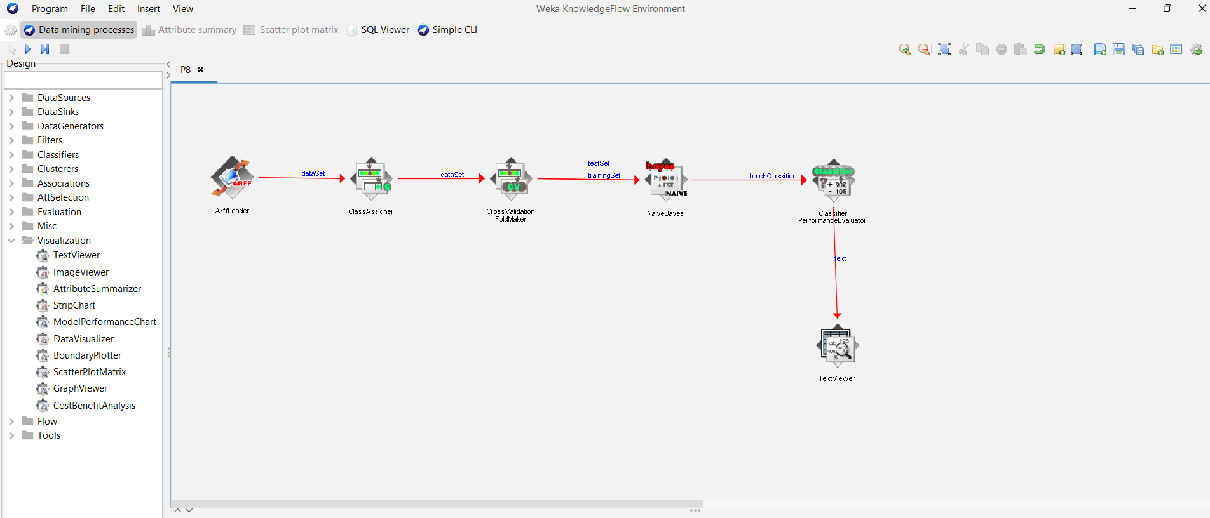
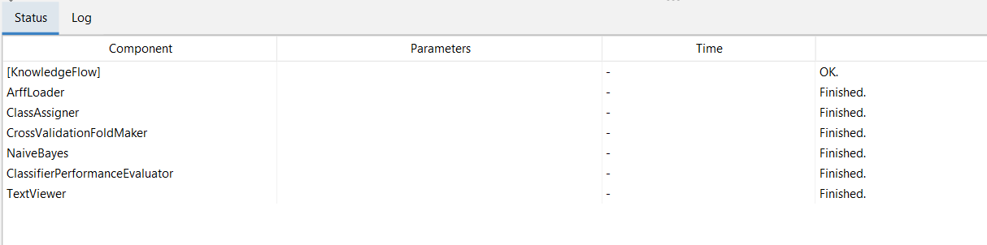
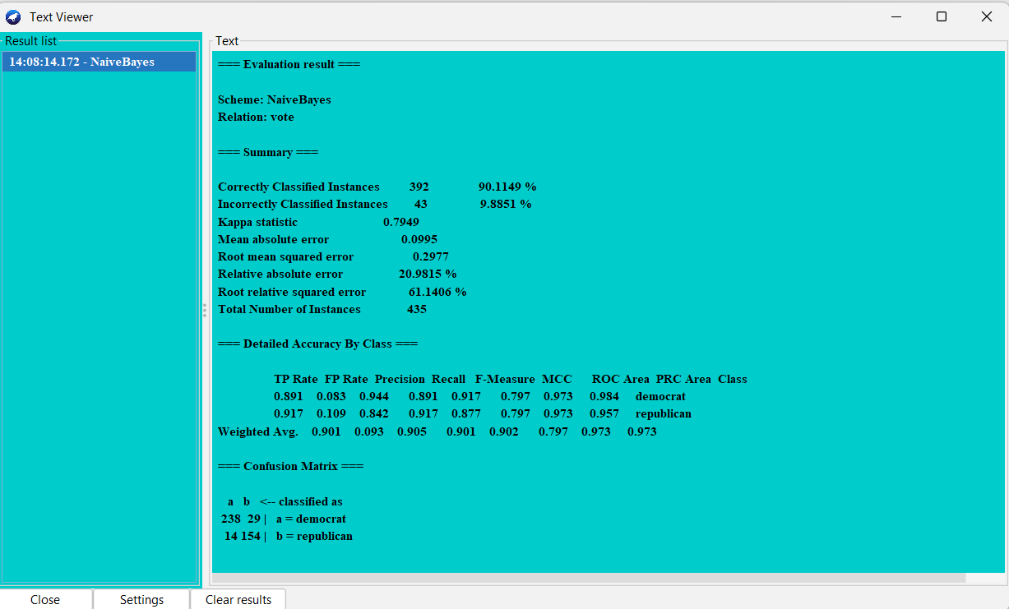

********************************************************************************
Excersise 21
Aim: Applying k-means clustering on a given data set.
Reg No. 24251115
Date 18-05-2025
********************************************************************************
